COLLINS JOSEPH MUNYAO MWAURA

C025-01-0638/2020

Photographic Essay on Body Markings and Piercings in African Communities

Body art, a form of self-expression deeply rooted in cultural traditions, holds a significant place in the diverse tapestry of African societies. This essay delves into the multifaceted world of body art in Africa, with a special emphasis on tattoos. As we unravel the cultural, social, and historical dimensions, we embark on a journey to understand how tattoos have been used as powerful symbols and expressions across the continent.

Body art in Africa traces its origins to ancient civilizations, where it served as a visual language that conveyed identity, status, and cultural affiliations. The use of natural pigments, scarification, and later, tattoos, became integral to tribal rituals, rites of passage, and even storytelling. Examining the historical context provides a foundation for comprehending the evolving role of body art, particularly tattoos, in contemporary African societies.

Africa's vast cultural diversity is mirrored in its body art practices. Tattoos, in particular, vary in style, design, and significance across different regions and ethnic groups. From the elaborate geometric patterns of the Berbers in North Africa to the symbolic designs of the Maasai in East Africa, each tattoo carries a unique cultural narrative. Exploring these variations unveils the intricate ways in which tattoos continue to be a dynamic cultural phenomenon.

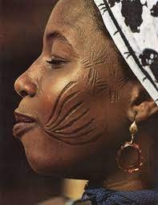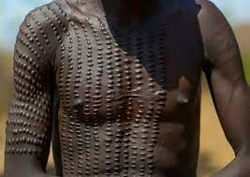

Beyond their cultural significance, tattoos in Africa often bear social implications. In some societies, specific tattoo designs signify one's social status, achievements, or even marital status. The permanence of tattoos adds weight to the symbols they carry, fostering a sense of identity and community. This section examines how tattoos act as social markers, fostering a connection between individuals and their communities.

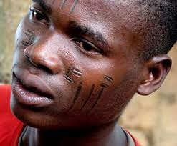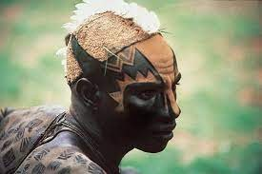

In recent years, there has been a resurgence of interest in traditional African tattoo artistry, coupled with a contemporary twist. Tattoo artists across the continent are exploring innovative designs that incorporate traditional symbols into modern aesthetics. This fusion of the old and the new not only preserves cultural heritage but also contributes to the global conversation surrounding tattoo art.

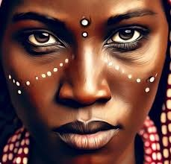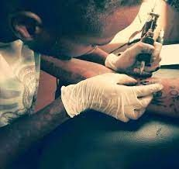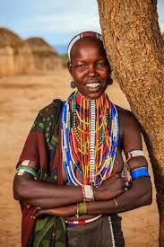

Despite the rich cultural heritage associated with tattoos in Africa, there exist challenges rooted in changing societal perceptions. Some communities view tattoos as a departure from tradition or even associate them with negative stereotypes. As African societies undergo rapid transformations, the evolution of perceptions towards tattoos becomes a nuanced dialogue between cultural preservation and individual expression. Understanding and navigating these

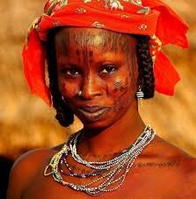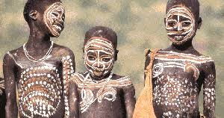

dynamics is essential for fostering a harmonious coexistence between tradition and modernity.

In conclusion, the canvas of body art in Africa, with a special focus on tattoos, is a

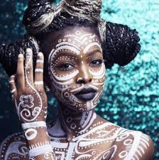

masterpiece that tells a story of cultural resilience, spiritual connectivity, and individual expression. From

the ancestral roots of traditional designs to the contemporary resurgence in modern Africa, tattoos and body painting serve as indelible imprints on the skin, etching a narrative that transcends time and space. As Africa continues to evolve, so too does the artistry of its tattoos, leaving an everlasting impression on the cultural landscape of the continent.